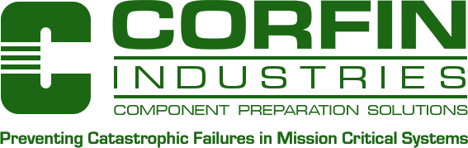

September 4, 2018

Subject: Corfin Industries LLC REACH Declaration Official Release

Reference: Regulation (EC) No. 1907/2006 of the European Parliament and of the Council of

18 December 2006 concerning the Registration, Evaluation, Authorization and

Restriction of Chemicals (REACH) within the supply chain

Corfin Industries LLC (CILLC), located at 7-B Raymond Avenue, Salem, New Hampshire 03079 is aware of Regulation (EC) No. 1907/2006 of the European Parliament and of the Council of 18 December 2006 concerning the Registration, Evaluation, Authorization and Restriction of Chemicals (REACH). This applies to the most recent additions on the list as of 4 September 2018.

The value add component processing performed by Corfin Industries LLC on customer supplied components does not contain any substances on the Candidate List of Substances of Very High Concern (SVHC).

Very best regards,

cid:image001.png@01D2C00A.BE56A100

Thomas J. Beaumier

Corfin Industries LLC

Compliance Manager

7-B Raymond Avenue

Salem, New Hampshire 03079 USA

+1 (603) 893-9900 (main)

+1 (603) 893-6800 (fax)

+1 (603) 912-4033 (office)