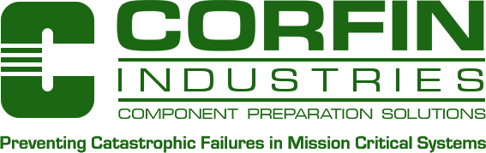

September 4, 2018

Subject: Corfin Industries LLC RoHS Declaration Official Release

Reference: Directive 2011/65/EU RoHS Directive within the supply chain

Corfin Industries LLC (CILLC), located at 7-B Raymond Avenue, Salem, New Hampshire 03079 is aware of RoHS Directive 2015/65/EU Restriction of Hazardous Substances (RoHS 2 and 3) and Directive 2011/65/EU RoHS Directive within the supply chain.

The value add component processing performed by Corfin Industries LLC on customer supplied components requires the use of Tin/Lead Solder (Sn63/Pb37) as contractually obligated by the purchase order flow down requirements.

Very best regards,

cid:image001.png@01D2C00A.BE56A100

Thomas J. Beaumier

Corfin Industries LLC

Compliance Manager

7-B Raymond Avenue

Salem, New Hampshire 03079 USA

+1 (603) 893-9900 (main)

+1 (603) 893-6800 (fax)

+1 (603) 912-4033 (office)